**Chapter 5**

**Multiple Integration**

**5.3 Double Integrals in Polar Coordinates**

**Section Exercises**

**In the following exercises, express the region  in polar coordinates.**

123.  is the region between the circles of radius  and radius  centered at the origin that lies in the second quadrant.

Answer: 

125.  is the region bounded by the -axis and 

Answer: 

127. 

Answer: 

**In the following exercises, the graph of the polar rectangular region  is given. Express ** in polar coordinates.**

129.

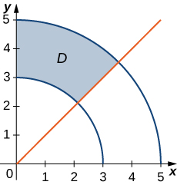

Answer: 

131.

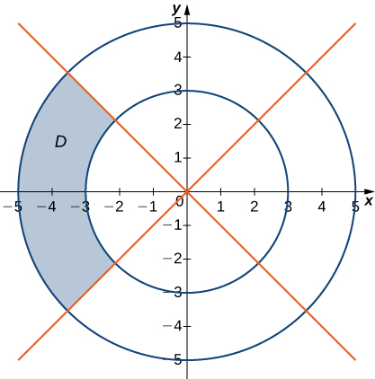

Answer: 

133. In the following graph, the region  is bounded by  and 

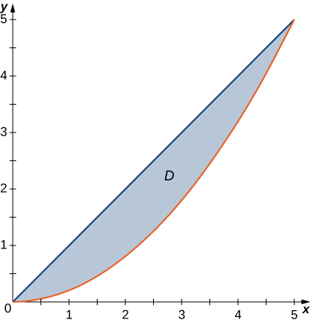

Answer: 

**In the following exercises, evaluate the double integral  over the polar rectangular region **

135. 

Answer: 

137. 

Answer: 

139.  where 

Answer: 

141.  where 

Answer: 

143. 

Answer: 

**In the following exercises, the integrals have been converted to polar coordinates. Verify that the identities are true and choose the easiest way to evaluate the integrals, in rectangular or polar coordinates.**

145. 

Answer: 

147. 

Answer: 

**In the following exercises, convert the integrals to polar coordinates and evaluate them.**

149. 

Answer: 

151. 

Answer: 

153. Find the area of the region  bounded by the polar axis and the upper half of the cardioid 

Answer: 

155. Find the total area of the region enclosed by the four-leaved rose  (see the figure in the previous exercise).

Answer: 

157. Find the area of the region  whichis the region inside the disk  and to the right of the line 

Answer: 

159. Determine the average value of the function  over the region  bounded by the polar curve  where  (see the following graph).

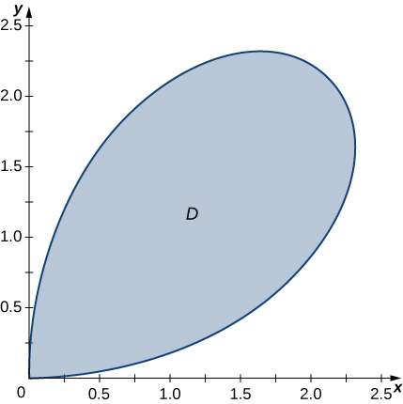

Answer: 

161. Find the volume of the solid bounded by the paraboloid  and the plane 

Answer: 

163. a. Find the volume of the solid  inside the unit sphere  and above the plane 

b. Find the volume of the solid  inside the double cone  and above the plane 

c. Find the volume of the solid outside the double cone  and inside the sphere 

Answer: a.  b.  c. 

**For the following two exercises, consider a spherical ring, which is a sphere with a cylindrical hole cut so that the axis of the cylinder passes through the center of the sphere (see the following figure).**



165. A cylindrical hole of diameter  cm is bored through a sphere of radius  cm such that the axis of the cylinder passes through the center of the sphere. Find the volume of the resulting spherical ring.

Answer:  

167. Find the volume of the solid that lies under the paraboloid  inside the cylinder  and above the plane 

Answer: 

169. Find the volume of the solid that lies under the plane  and above the unit disk 

Answer: 

171. Use the information from the preceding exercise to calculate the integral  where  is the unit disk.

Answer: 

173. Apply the preceding exercise to calculate the integral  where  is the annular region between the circles of radii  and  situated in the third quadrant.

Answer: 

175. Apply the preceding exercise to calculate the integral  where .

Answer: 

177. Evaluate  where 

Answer: 

179. In statistics, the joint density for two independent, normally distributed events with a mean  and a standard distribution  is defined by  Consider  the Cartesian coordinates of a ball in the resting position after it was released from a position on the *z*-axis toward the -plane. Assume that the coordinates of the ball are independently normally distributed with a mean  and a standard deviation of  (in feet). The probability that the ball will stop no more than  feet from the origin is given by  where  is the disk of radius *a* centered at the origin. Show that 

Answer: This is a proof; therefore, no answer is provided.

This file is copyright 2016, Rice University. All Rights Reserved.